1. Visualization for 1980 MERRA2 Data

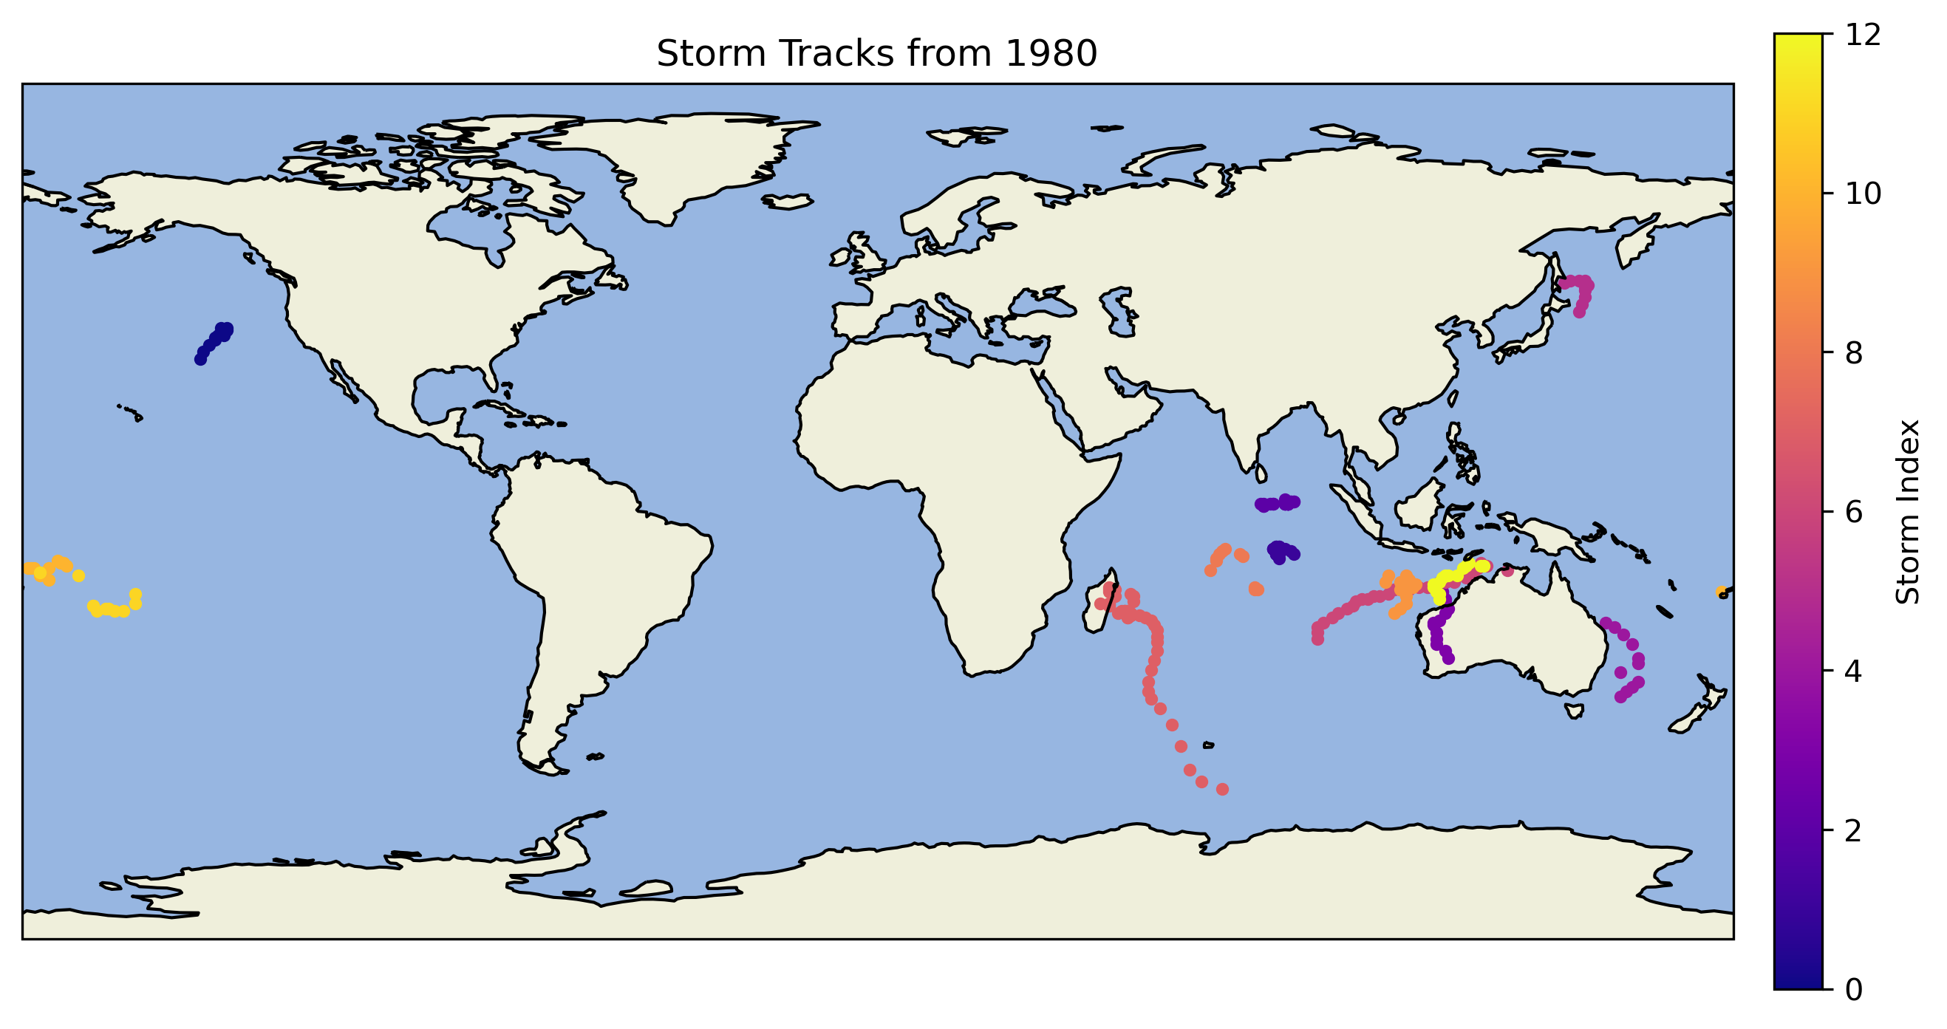

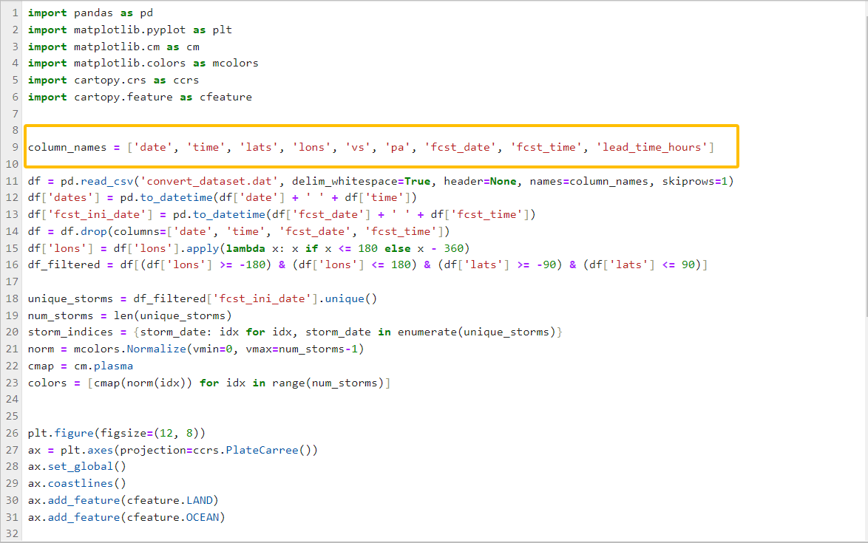

Based on the previous code, I added the contents in the orange box so that the reading process can match the original data form.

1. IBTrACS

Visualization for 2022 IBTrACS Data

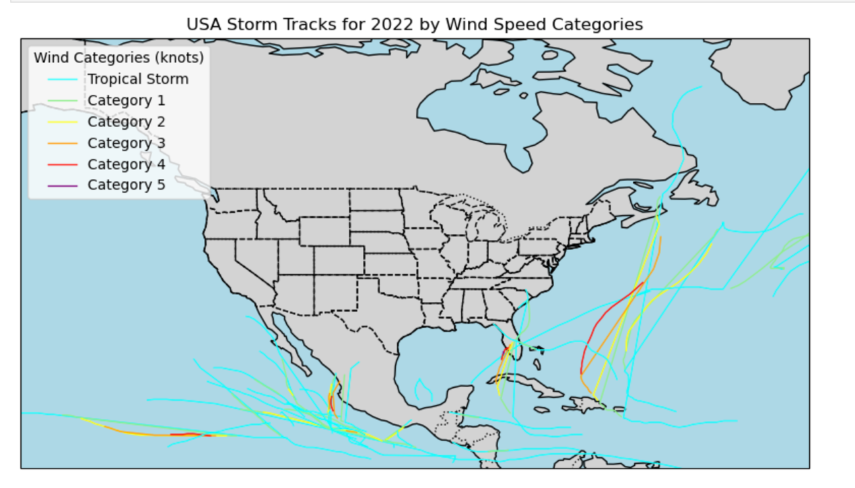

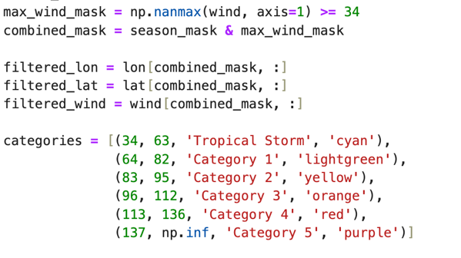

I add the constraint of max wind speed larger or equal to 34k, and classify the storms based on

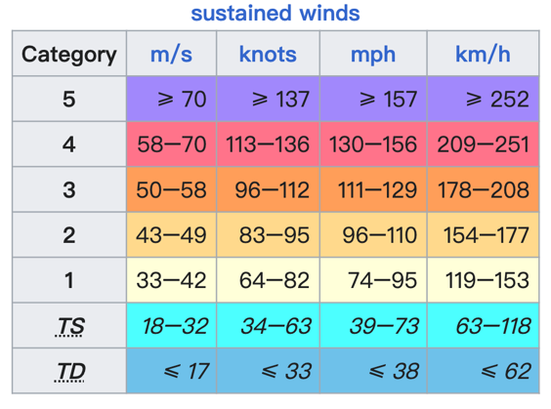

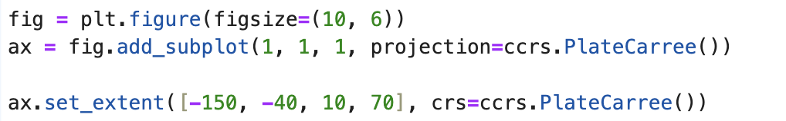

By setting the boundary of lat and lon to plot the graph.

I also plotted the graph of Number of Unique Storms per Month in 2022 (WMO_WIND >= 34)

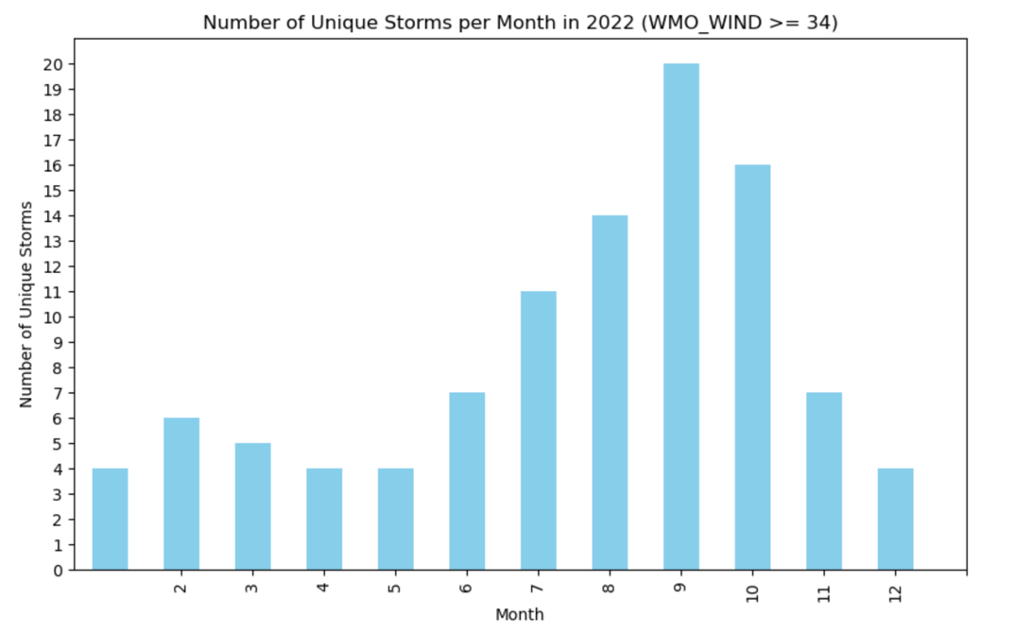

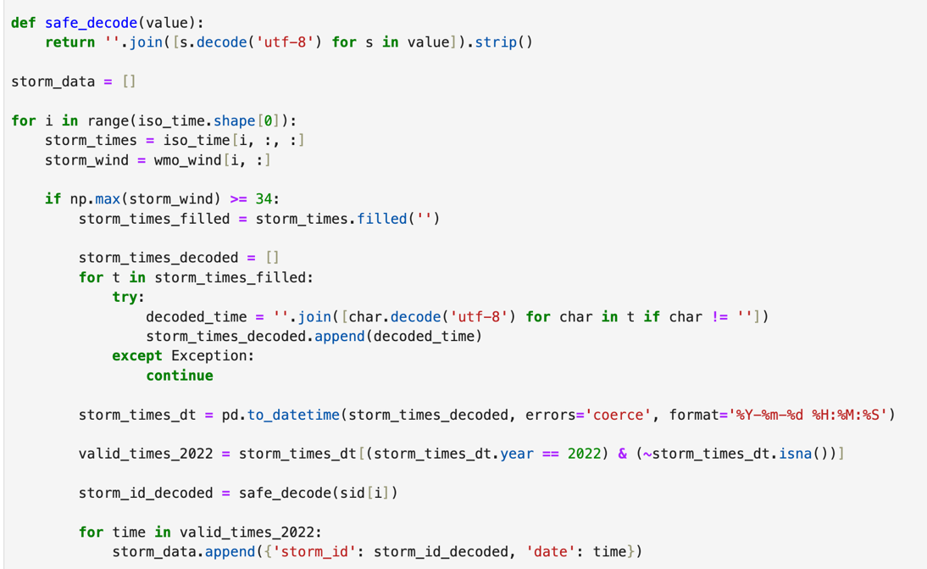

I decoded the time of storm in order to extract the year and month. Then searched the storm with max wind speed larger or equal to 34k globally and plotted the number of storm per month.

I also plotted Number of Unique Storms per Month per Basin in 2022 (Max Wind Speed ≥ 34)

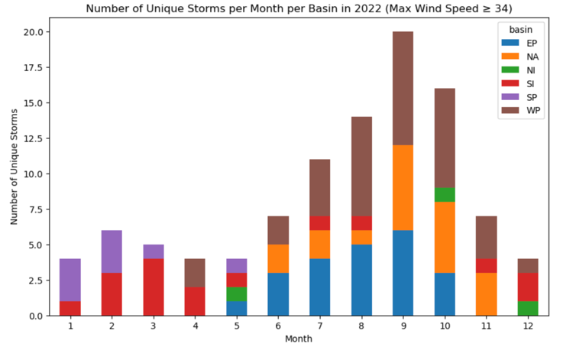

Using the same idea and added the basin in this time.

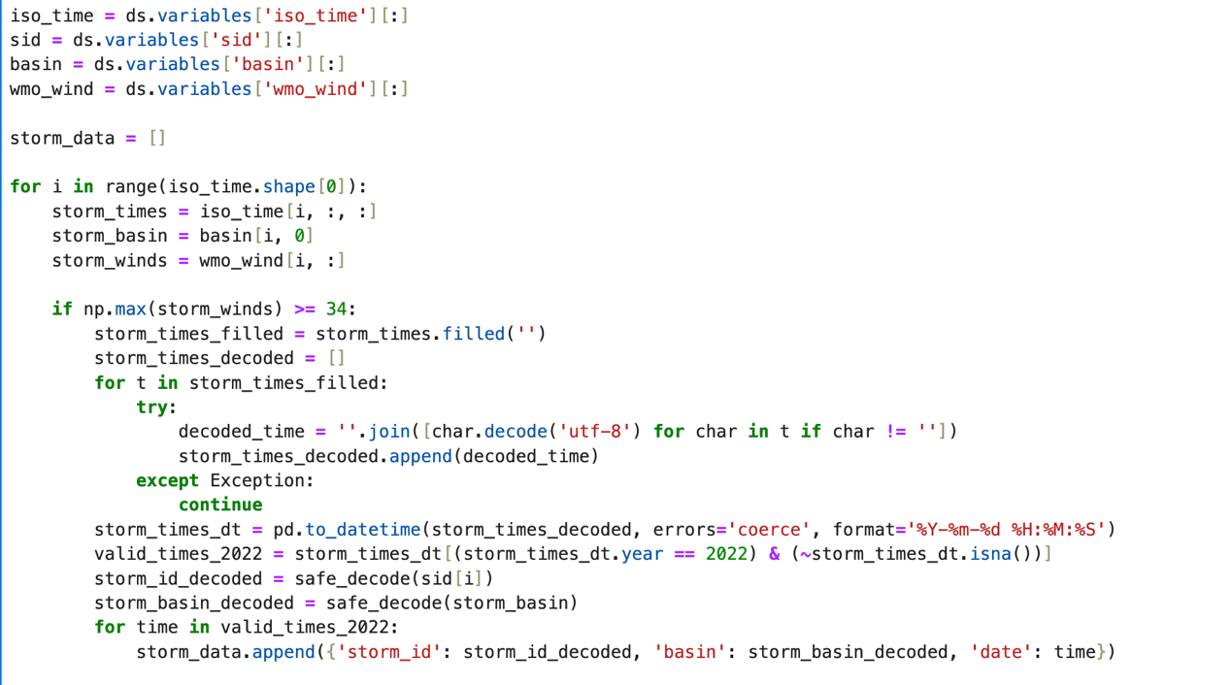

1. ERA_data_2022

We use **data.py** to download the data that can make TE work.

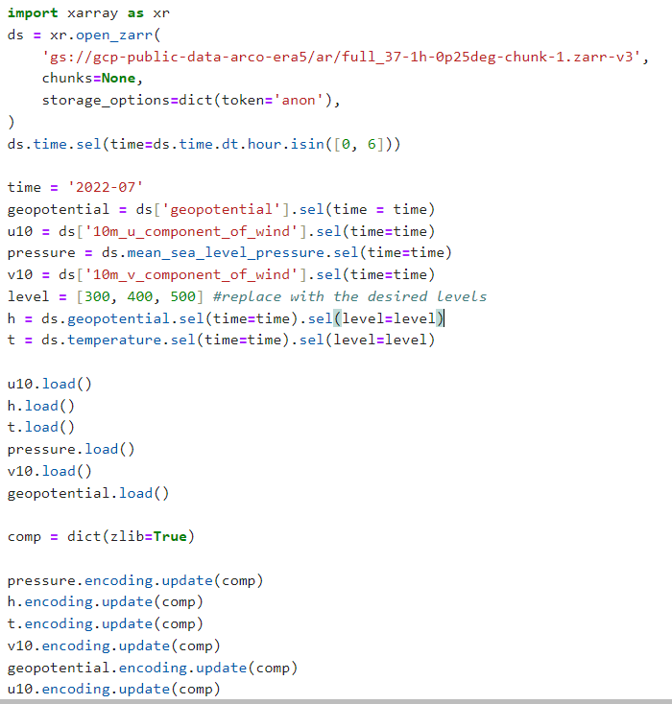

Then, we use ncdump -h to obeserve the data form of each variable.

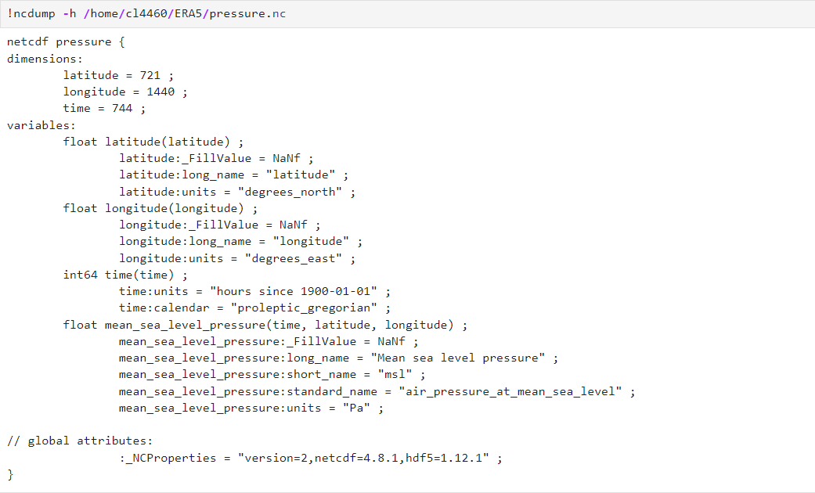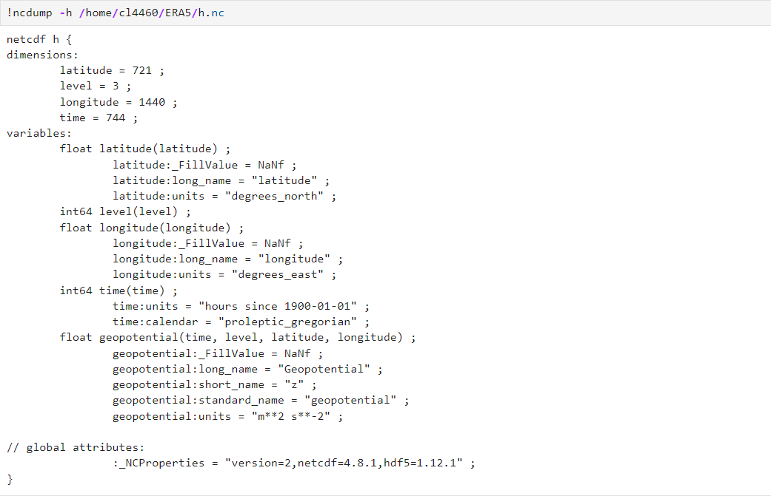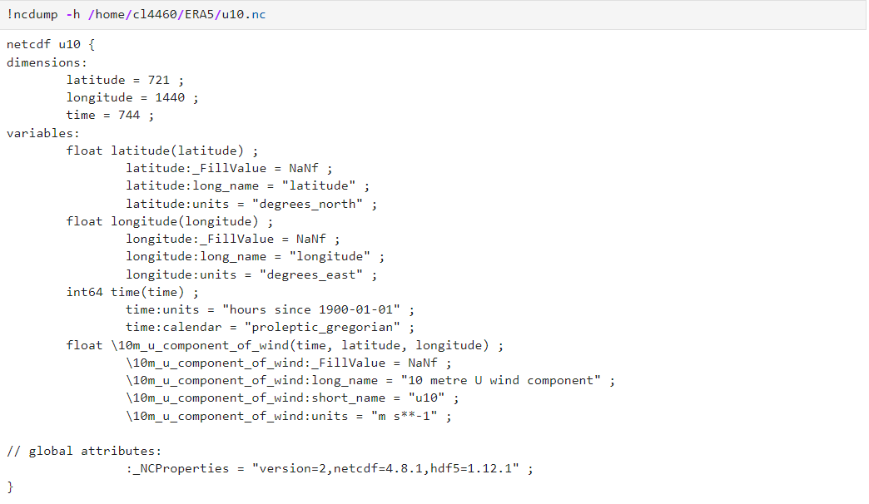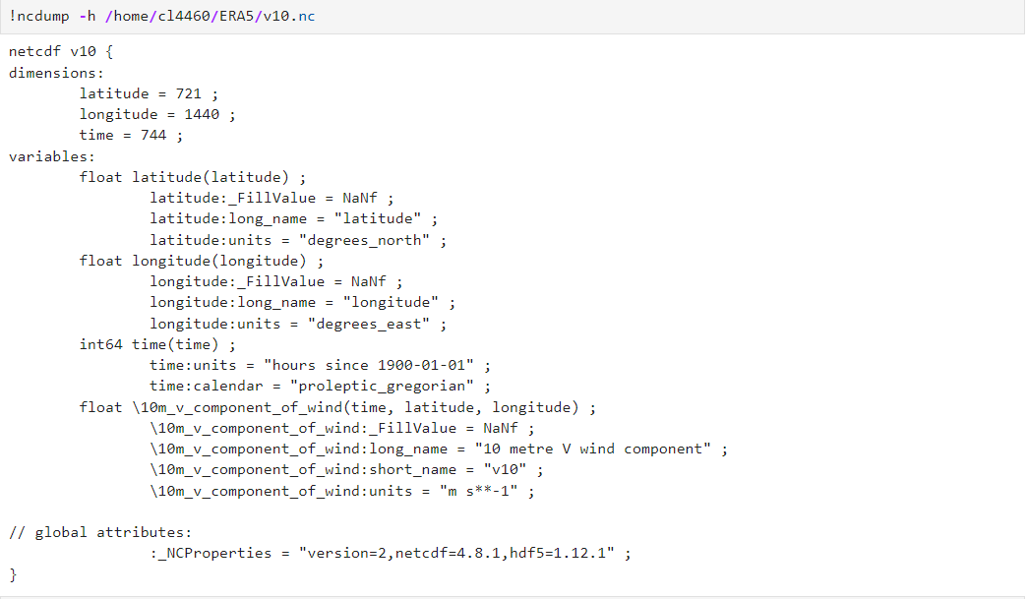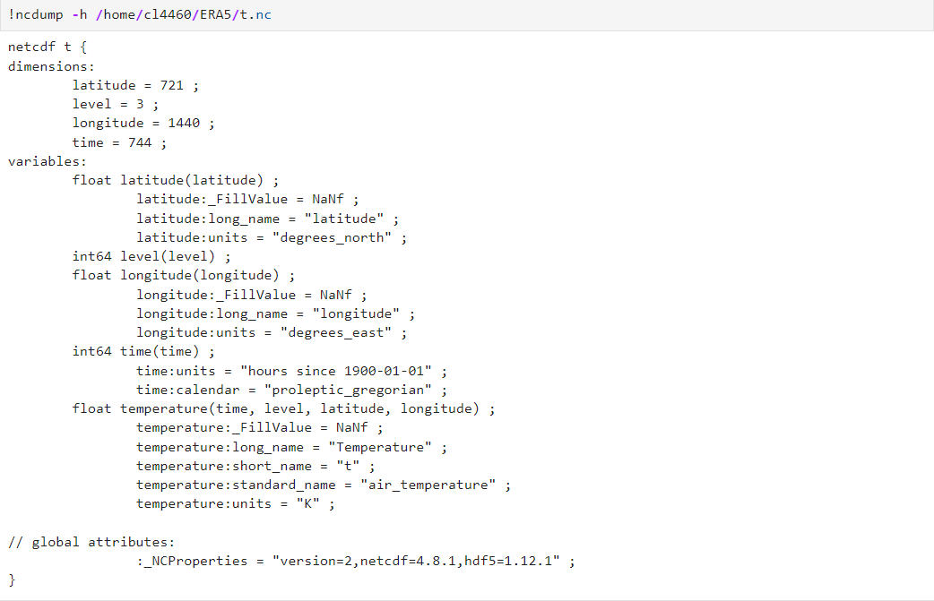

After we know the details of each variable, we try to implement get_topo.py and mergedata.py to get the following datasets (ERA5_topo.nc and ERA5_combined.nc) to match the requirement of running TempestExtremes.

